Professor Mark S. Micale History 142/143
Department of History Fall Semester, 2017
309 Gregory Hall 150 Animal Sciences Lab
E-mail: msmicale@illinois.edu Tuesdays and Thursdays,
10:00-10:50 A. M.

History 142/143
European Civilization:
1750 to the Present

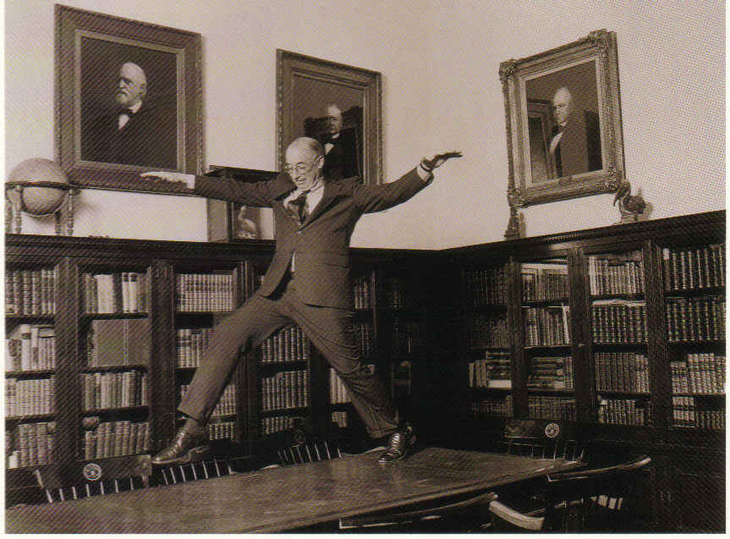
“Western Civilization.” Photograph by Suzanne Opton (1993)

Course Content: The past 300 years in Europe have been extraordinarily eventful. This introductory course will examine a sequence of historical episodes during this long, dramatic, and turbulent period in European history with particular attention to the period running from the middle of the eighteenth century to the middle of the twentieth century. Geographically, the course will focus on Britain, France, and German-speaking central Europe with occasional collateral consideration of Italy, Spain, Eastern Europe, and Russia/Soviet Union. We will study many aspects of the European historical experience, but especially events in politics, society, culture, and thought. The course is divided into four great geochronological units: 1) The Age of the French Revolution; 2) Victorian Britain; 3) Europe and World War One; and 4) The Age of the Great Dictators.

Assigned Course Books:

Friedrich Engels, The Condition of the Working Class in England (1844)
Erich Maria Remarque, All Quiet on the Western Front (1929)
Yevgeny Zamyatin, We (1919)

In addition, a customized collection of documents and articles, titled European Civilization: 1750 to the Present, second edition, is required. This Course Reader has been prepared and printed just for our course, so be sure to acquire a copy; we will be reading nearly everything in it. Please purchase the second edition, since it includes several new documents.

The course books, including the Course Reader, are now available for purchase at the Illini Union Bookstore in affordable paperback editions.

Course Requirements and Grading:

a) attendance at and participation in your weekly discussion section (20%)
b) four in-class quizzes (10% apiece = 40%)
c) two written assignments (20% apiece = 40%)

Schedule of Lectures and Readings

1) August 29: Introduction to Modern European History

Unit One:
The Age of the French Revolution

2) August 31: The European Enlightenment

Weekly Readings: Frontispiece to the Diderot Encyclopedia (1751); Immanuel Kant, "What Is Enlightenment?" (1784), both in the Course Reader (documents #1 and #2).

3) September 5: The French Revolution: The Moderate Phase

Weekly Readings: Frontispiece to the Diderot Encyclopedia (1751); Immanuel Kant, "What Is Enlightenment?" (1784), both in the Course Reader (documents #1 and #2); textbook chapter in the FR distributed by Professor Micale.

4) September 7: The French Revolution: The Radical Phase

5) September 12: History of the Guillotine (video documentary)

6) September 14: The Napoleonic Sequel

Weekly Readings: Thomas Jefferson, "Declaration of Independence" (1776); "Declaration of the Rights of Man and the Citizen" (1789); “Timeline of Revolutionary and Napoleonic Europe,” all in the Course Reader (documents #3, #4, and #5).

7) September 19: The Rise of European Conservatism

Reading: Edmund Burke, Reflections on the Revolution in France (1790), excerpt in The Course Reader

8) September 21: in-class quiz #1

Unit Two:
Victorian Britain

9) September 26: The Making of the European Middle Class

10) September 28: The Cult of Progress and the Great Exhibition of 1851

11) October 3: Critiques of Capitalism and Industrialism

Weekly Reading: Engels, Condition of the Working Class in England (1844), 27-110, 223-246, 275-292.

12) October 5: Darwin and the Darwinian Revolution

Weekly Readings: "Genesis," The New English Bible; Charles Darwin, The Descent of Man (1871), selections, both in Course Reader (documents #10 and #11).

13) October 12: The Eugenics Movement (guest lecture by Stephen Vitale)

Readings: To be assigned

14) October 10: Europe's Imperial Surge, 1880-1914

Weekly Readings: Louis I. Snyder, ed., The Imperialism Reader, several short readings that are pro- and anti-empire, in Course Reader (documents #12)

15) October 17: European Feminism during the Long Nineteenth Century

Weekly Readings: writings by Olympe de Gouges (1791), Mary Wollstonecraft (1792), John Stuart Mill (1869), Clara Zetkin, (1892); Emmeline Pankhurst, (1913), and Alexandra Kollontai (1926), all in the Course Reader (documents, #15-#20).

16) October 19: In-class quiz #2

Unit Three:
Europe and World War One

17) October 24: The Great War of 1914-1918

Reading: Erich Maria Remarque, All Quiet on the Western Front (1929), entire novel; textbook chapter on WW1 distributed by Professor Micale

18) October 26: Shell Shock

19) October 31: War Art (a video documentary narrated by Eddie Redmayne)

20) November 2: 1917 Bolshevik Revolution in Russia (guest lecture by Felix Cowan)

Reading: to be assigned

21) November 7: Weimar Culture (including German cabaret songs from the 1920s)

22) November 9: In-class quiz #3

Unit Four:
The Age of the Great Dictators

23) November 14: The Fascist Worldview

Weekly Readings: Benito Mussolini, "The Doctrine of Fascism" (1932); Adolf Hitler, Mein Kampf (1925), selections, both in the Course Reader (documents #21 and #22).

24) November 16: The Nazi Dictatorship in Germany, 1933-1939

Weekly Readings: the text of Nazi laws against Jews, gypsies, homosexuals, and the disabled (1933-1938), in the Course Reader (documents #23-#26).

25) November 28: The Holocaust

Weekly Readings: Raphael Lemkin, “Genocide” (1946); Leni Yahil, The Holocaust: The Fate of European Jewry (1990), Table E.1; Michael Shermer, "How We Know the Holocaust Happened: Debunkers and Deniers" (1997), all in the Course Reader (documents #27, #28, and #31).

26) November 30: The Spanish Civil War, 1936-1939 (documentary video)

27) December 5: Stalinism in the USSR, 1928-1953

Weekly Reading: Yevgeny Zamyatin, We, a dystopian novel written in 1919, first half

28) December 7: Russian and Soviet Poster Art (in-class discussion with Professor Micale)

29) December 12: The Political Novel in the Age of Totalitarianism: Orwell, Huxley, Zamyatin

Weekly Reading: Yevgeny Zamyatin, We, full novel

Final Examination: Quiz #4, date and time to be announced

